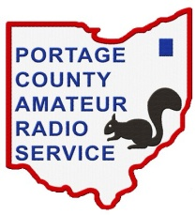
Portage County Amateur Radio Service, Inc. - K8BF A-Z AWARD - Flex Net User Log

Name/Call Sign:
Date: | Time Start: | Time End:
Frequency:

# | Call Sign | Name | UTC | SENT | RECD | NOTE
1 |  |  |  |  |  | Net Control
2
3
4
5
6
7
8
9
10
11
12
13
14
15
16
17
18
19
20
21
22
23
24
25
26
27
28
29
30
NOTES:

Rev 11 April 2019

