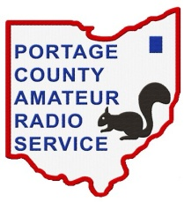
Portage County Amateur Radio Service, Inc. - K8BF - Flex Net Control Log

Net Control Name/Call Sign: |  | Frequency:
Date: | Time Start: |  | Time End:
Total number of check-ins (including Net Control):

# | Call Sign | Name | Location | Comments
1 |  |  |  | NET CONTROL
2
3
4
5
6
7
8
9
10
11
12
13
14
15
16
17
18
19
20
21
22
23
24
25
26
27
28
29
30
Announcements:
Rev 11 April 2019

